**DAILY ONLINE ACTIVITIES SUMMARY**

|  |  |  |  |  |  |  |  |  |
| --- | --- | --- | --- | --- | --- | --- | --- | --- |
| **Date:** | **21-05-2020** | | | | | **Name:** | **Deril Quadras** | |
| **Sem & Sec** | **8 A** | | | | | **USN:** | **4AL16CS031** | |
| **Online Test Summary** | | | | | | | | |
| **Subject** | | **SMS** | | | | | | |
| **Max. Marks** | | **60** | | **Score** | | | **58** | |
| **Certification Course Summary** | | | | | | | | |
| **Course** | **Introduction to AWS Fargate** | | | | | | | |
| **Certificate Provider** | | | **AWS** | | **Duration** | | | **10 mins** |
| **Coding Challenges** | | | | | | | | |
| **Problem Statement:**   1. **Reverse a single linked list using c.** 2. **program in Python to find Area-Circle, Circumference-Circle, Area-Square, Circumference-Square using functions with menu** | | | | | | | | |
| **Status: Solved** | | | | | | | | |
| **Uploaded the report in Github** | | | | | **Yes** | | | |
| **If yes Repository name** | | | | | **Derilquadras/online_c_coding_repository** | | | |
| **Uploaded the report in slack** | | | | | **Yes** | | | |

Online Test Details: (Attach the snapshot and briefly write the report for the same)

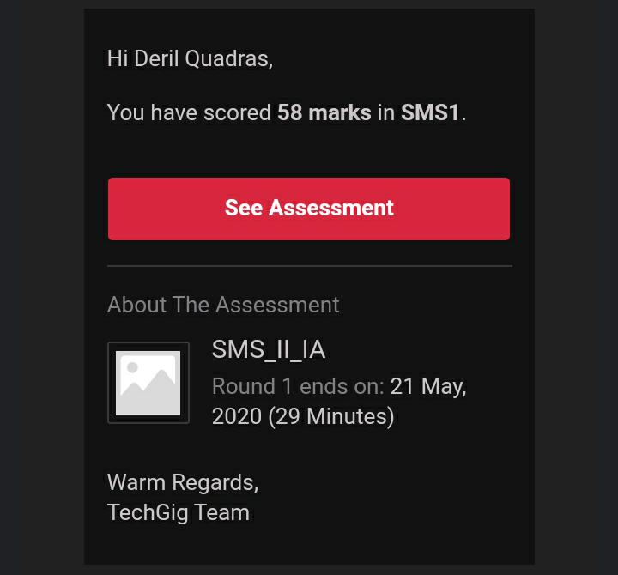

Certification Course Details: (Attach the snapshot and briefly write the report for the same)

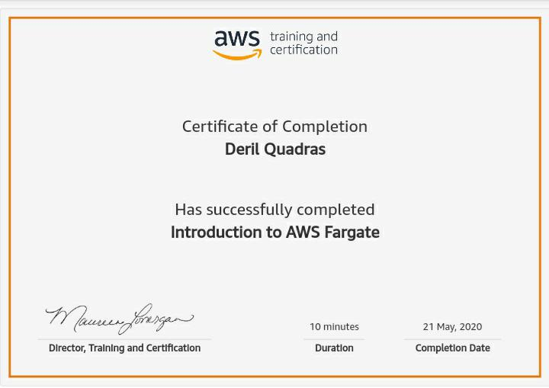

Coding Challenges Details: (Attach the snapshot and briefly write the report for the same)

**PROGRAM 1 . Reverse a single linked list using c**

**#include<stdio.h>**

**#include<stdlib.h>**

**struct Node**

**{**

**int data;**

**struct Node* next;**

**};**

**static void reverse(struct Node** head_ref)**

**{**

**struct Node* prev   = NULL;**

**struct Node* current = *head_ref;**

**struct Node* next;**

**while (current != NULL)**

**{**

**next  = current->next;**

**current->next = prev;**

**prev = current;**

**current = next;**

**}**

**\*head_ref = prev;**

**}**

**void push(struct Node** head_ref, int new_data)**

**{**

**struct Node* new_node = (struct Node*) malloc(sizeof(struct Node));**

**new_node->data  = new_data;**

**new_node->next = (*head_ref);**

**(*head_ref)    = new_node;**

**}**

**void printList(struct Node *head)**

**{**

**struct Node *temp = head;**

**while(temp != NULL)**

**{**

**printf("%d  ", temp->data);**

**temp = temp->next;**

**}**

**}**

**2**. **Program in Python to find Area-Circle, Circumference-Circle, Area-Square, Circumference-Square using functions with menu**

#main.py

def AreaCircle(r):

return rr

def CircumferenceCircle(r):

return 23.14*r

def AreaSquare(b,h):

return bh

def CircumferenceSquare(h):

return 4h

#pm.py

from main import*

r=float(input("Enter Radius Of Circle: "))

ac=AreaCircle(r)

print("Area Of Circle: ",ac)

cc=CircumferenceCircle(r)

print("Circumference Of Circle is: ",cc)

b=float(input('Enter Base Of Square: '))

h=float(input('Enter Height Of Square: '))

As=AreaSquare(b,h)

print("Area Of Square Is: ",As)

cs=CircumferenceSquare(h)

print("Circumference Of Square Is: ",cs)